**A complex systems framework for studying American representational systems**

Samuel S.-H. Wang*1, Jonathan R. Cervas2, Bernard N. Grofman3

1Neuroscience Institute, Princeton University, Princeton, New Jersey 08544 USA.

2Institute for Politics and Strategy, Carnegie-Mellon University, Pittsburgh, Pennsylvania USA.

3Department of Political Science, 3151 Social Science Plaza, University of California, Irvine CA 92697-5100

*Corresponding author.

Sam Wang

Electoral Innovation Lab

Neuroscience Institute, Washington Road

Princeton University

Princeton, NJ 08544

(609) 258-0388

sswang@princeton.edu

**In the United States, representation can be unreflective of public opinion, and legislators unresponsive to their constituents. Electoral institutions fail to address these problems, or worse, can be manipulated to intensify these problems. The resulting distortions lead to polarized institutions and privilege a faction of voters at the expense of the majority. Here we organize causes and possible repairs for these distortions into a complex systems framework. In engineering and biology, models of systems include interaction mechanisms with distinct dynamical properties. Interaction mechanisms that may affect representation include nonlinearities and amplification (voting rules), positive feedback mechanisms (gerrymandering), and integration over time (lifetime judicial appointments). Reforms to the electoral process such as ranked-choice voting, open primaries, and redistricting reform have the potential to remediate these problems and reduce polarization. An understanding of how these complex mechanisms interact can help not only scholars, but aid reformers in designing effective and lasting outcomes.**

**THE SCIENCE AND ENGINEERING OF REPRESENTATIVE DEMOCRACY**

In the face of record distrust and dissatisfaction with respect to American institutions, interest in reform measures has exploded. Ideas for reform range from ranked-choice voting to redistricting reform to changes in the judiciary. However, no matter how well-intended such reforms may be, their consequences are not always easy to predict. We hope to provide a perspective based on complex systems that will enhance the efforts to date of reformers and academics, and create a framework for diagnosing and remediating bugs in democracy. Our approach promises to identify which steps might have the most leverage in achieving the intended goals, while avoiding undesirable, unexpected outcomes.

In engineering or biology, one often encounters complex systems of interacting parts. Systems may be designed, such as a power grid or a mechanical clockwork, or arise through selection mechanisms, such as animal population dynamics or the evolution of new species. In both cases, a full understanding of a system’s behavior requires understanding both individual rules, network interactions, and the effects of exogenous factors.

A complex-systems approach reinterprets the science of politics in terms of the conceptual goals of engineering. Government arises from a combination of designed and naturally-arising features that include institutions, demographics, and geographic variation. We propose to describe the U.S. system of representative democracy in terms of how these features interact to form a complex system. This approach will draw upon individual political science investigations, which often concern themselves with identifying and quantifying effects and causality of discrete components of the system. An engineering-inspired approach seeks to assess the emergent behavior that arises when such features work together, identify nonlinear interactions, and help understand events that go outside past experience.

One of the difficulties of understanding reforms is that symptoms are distant from causes. Just as a stress hormone response occurs in response to both a traumatic injury and to a normal need to mobilize energy for exertion, negative events in representative democracy reflect a variety of causes. Coming up with a treatment for what ails democracy requires some understanding of how remedies may lead to an abatement of symptoms – and whether the treatment is beneficial in the long run, or interferes with other treatments.

An engineering-inspired approach must include measures of functionality. Here we will focus on three features of representative democracy: (1) representation that is commensurate with public opinion, (2) responsiveness of legislators and other public officials to changes in opinion, and (3) deliberation in the production of policy outcomes. Such ideals are implicit in the Constitution, federal, and state law. We suggest these as measures to diagnose the system’s health. We argue that this approach should guide the design of robust reforms that are effective, appropriate to specific localities, and lasting in their impacts.

**PRIOR CONDITIONS: POLARIZATION, RACE, AND GEOGRAPHY**

Formal institutions are embedded in wider society. A central design challenge arises from the fact that the wider society undergoes continual change. In the United States of 1790, voters comprised white male landowners and slaveowners in a nation of 4 million. Today, nearly all adult citizens can in principle vote in a nation of 330 million. Institutional changes have included the establishment of modern Electoral College rules, direct election of Senators, and a host of constraints on equal voter power. Those same institutions now face a set of challenges rooted in current conditions.

**Root causes of voter polarization.** A central feature of discussions of modern U.S. politics is polarization, the sorting of political stances along a single dimension, especially with bimodality and/or a high standard deviation. Since the 1970s, elected representatives have been sorted more and more reliably along a single dominating ideological dimension (McCarty, Poole, & Rosenthal 2008). This tendency toward single-dimension ideology has converged with the US system of single member districts, which creates strong incentives to reduce party structures to two major competing choices (Duverger 1954).

Institutions cannot explain polarization, since the recent increase in polarization (Putnam and Garrett 2020) occurred without major changes in the rules of democracy. Other causes include increasing distrust in institutions, the advent of long-distance rapid communication, demographic change, increasing economic inequality (Piketty and Saez, 2003), and loss of a commonly defined factual basis for civil society (Wattenberg 2004; Prior 2007; Groeling 2008; Prior 2013). These factors may act through institutions to create governmental polarization, or act as amplifiers of polarization arising by other causes (Duca and Saving 2016; Putnam and Garrett 2020; Stewart, McCarty, and Bryson 2020).

Demographic change is a major source of fragmentation. The population structure of the nation has been reshaped profoundly by the Hart-Celler Immigration and Naturalization Act of 1965. Overall, the Democratic party is becoming a coalition of ethnic minority groups and college-educateds and tilting toward women. Surveys of K-12 students and younger voters show that younger voters are turning away from the Republican Party, and will likely continue to do so for the next decade. More are identifying as political independents, though often throwing in their lot with the Democratic Party.

On the other side, the Republican Party has become increasingly a white, mostly non-college-educated group, a shrinking category. The overall result is an ethnicized party system. The growth and diversification of the Democratic coalition supports the view of many scholars (for example see Balkin, 2020) that at some point in the future, they will become the next dominant political party. However, the phrase “at some point in the future” is limited by the institutions and rules of democracy.

**Survival routes for a minority party.** Advantages like partisan gerrymandering and lifetime appointments to the judiciary are attempts to hold back the tide of a natural force, demographic change. The Republican Party, instead of adopting a strategy to expand its base, has chosen these tricks – building advantages for itself into the rules of government – as a route to political survival. Such maneuvers diminish the responsiveness of government to Democratic and Republican voters alike, by building institutions that are unresponsive to voter sentiment.

Ideological lines have hardened, with partisans holding correlated issue positions across seemingly independent issues such as environmental protection, immigration, taxation, and gay marriage (Fiorina and Abrams 2008). Voters who identify as Republicans have very different beliefs than Democrats on factual matters such as the extent of racial discrimination, evidence for global warming (Tesler and Sears, 2010), and fictitious claims of fraud in the 2020 election (Quinnipiac 2020). These divisions are accompanied by a rise of negative partisanship (Abramowitz and Webster 2018), i.e. the dislike of the other political party, and “affective polarization”, i.e. dislike of individuals who identify with the other party (Iyengar et al. 2019), including an increase in the percentage of parents unwilling to see their children marry across party lines (﻿Iyengar, Sood, and Lelkes 2012).

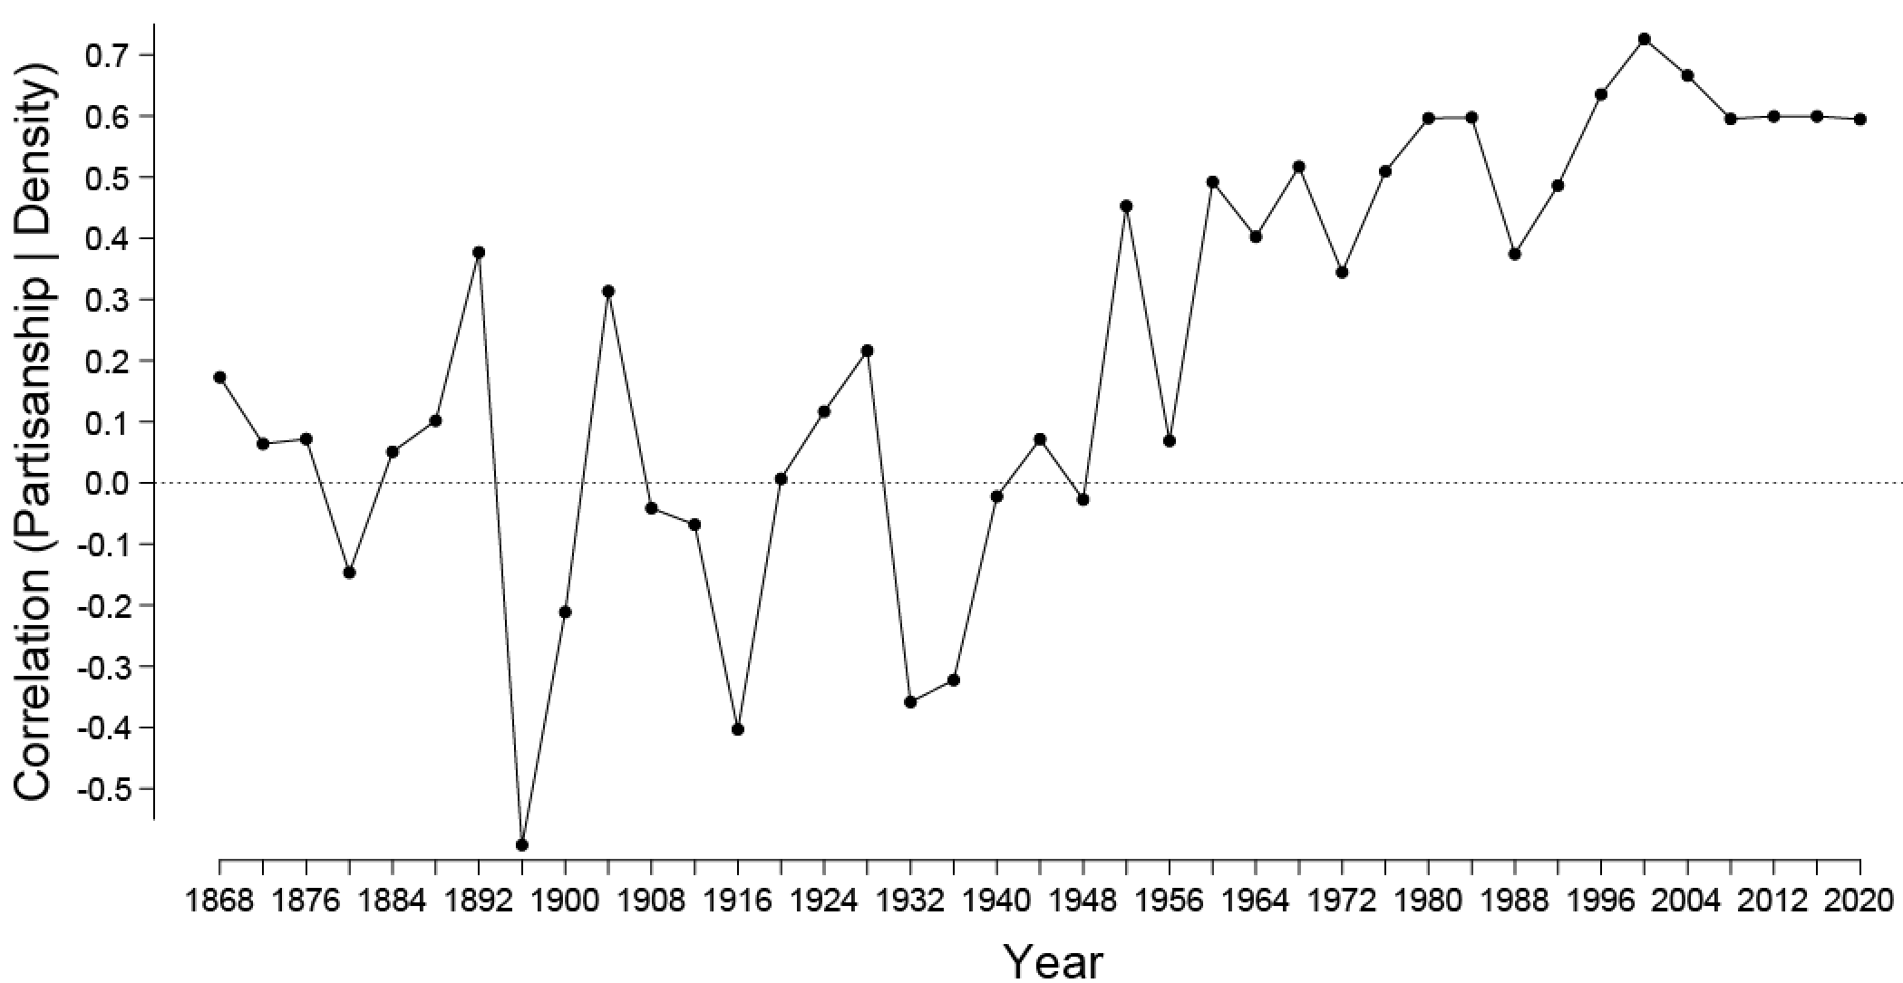

**Figure 1. State-by-state correlation between partisanship and population density, 1868-2020.** Spearman rank correlations were calculated.

**The urban-rural divide and partisan skewness.** Despite the reduction of dimensionality of politics to a single polarized axis, one feature has remained heterogeneous: geographic variation in political stances. Indeed, political polarization has taken on a spatial dependence that in turn creates representational distortions. Patterns of which states are safely Democratic and Republican have varied considerably over the last 100 years. Despite those shifts, a consistent trend emerged starting around 1960: a sustained correlation between population density and partisan preference (**Figure 1**). By 1968, the distribution of partisan preference showed a strong skew, with high-density states much more Democratic without strong but weaker Republican tendencies in low-density states (skewness=0.68 to 2.68, average 1.31, 1968 to 2020). Geographic patterns of immigrant location (Massey 2007), and the continuing economic decline of rural areas have meant that Democratic cities face a Republican countryside, with the areas “in play” mostly suburban ones (Rodden 2019).

In a winner-take-all system, such a pattern gives advantages to Republicans because their votes are distributed to obtain wins by smaller margins.The advantage conferred by this geographic-partisan association favors Republicans in the Electoral College, such that a popular-vote loss by 3 points still gives an even-odds chance of winning the Presidency (Cervas and Grofman 2020b). The same density-partisanship correlation persists at a county and precinct level. Thus a partisan advantage also accrues when Congressional or legislative districts are drawn purely on the basis of compactness and preserving county/city boundaries. This inequity can be counteracted or intensified if redistricting is done to satisfy other criteria such as racial fairness or equal treatment of the major political parties. The urban-rural-derived partisan advantage is even larger in the Senate, which assigns two Senators per state irrespective of population (Dahl 2003; Cervas and Grofman 2020).

**Close partisan divisions.** The foregoing inequities of representation take on outsized importance when the two parties are closely divided in strength, as they have been for the last 20 years. In this situation substantial advantage comes from small gains in support that lead to a change in control of government. Such close partisan division has occurred for two extended periods in Congressional and Presidential politics, the first Gilded Age (1876-1896) and modern times, a second Gilded Age (1994 to present). With so much at stake, tactics may take a more confrontational tone of “Constitutional hardball” (Tushnet 2004) in which governing norms are broken and rules are bent and even broken in the service of gaining advantage. Any institutional rules that would give a long-lasting advantage, such as lifetime judicial appointments, would provide an incentive to engage in hardball tactics. Incivility and norm violation by one side will ultimately be met with further incivility and norms violation when the other side returns to power.

**BUGS IN DEMOCRACY: DECISION RULES, FEEDBACK, AND HYSTERESIS**

Citizen-level polarization is translated into defective government through electoral institutions. Those institutions, established over a period of many years, establish the composition and operation of all three branches of the federal government, as well as state-level officials. The rules by which the institutions operate have the potential to amplify or reduce the effects of voter polarization, and even influence voter polarization itself. Rules also add distortions that impede the deliberative process. Institutional rules entrench equities, inequities, and other features of the system, for good or bad (Starr 2020).

These rules are the object of considerable study. We will describe deficiencies in the rules in terms of principles found in complex systems and behavioral science.

**Amplification and distortion through voting rules.** Voting rules determine how voter polarization is translated to representational polarization. If polarized voters elect polarized legislators, incentives for compromise are reduced. When issue positions are correlated with one another along a single axis of variation, fewer opportunities arise to pursue legislative outcomes that command bipartisan support. Thus electoral mechanisms that generate legislative polarization might be expected to lead to gridlock and partisan warfare.

The most common rule for electing legislators in the United States is by plurality, or first-past-the-post. Under this rule, winners are only guaranteed to command majority support if there are two candidates. And if the available viable candidates, of which there are usually two, represent extreme ideological positions, a polarized legislator is elected. The two major candidates are elected in a partisan primary election, where there may be many candidates, in which case the nominee can prevail with less than half of the vote. Thus a determined minority, including one composed of extremists, may potentially determine one or both nominees. In short, with plurality voting and partisan primaries, the pivotal voter in determining a winner is often different from the median voter.

A quintessential example of such a nominee is former President Donald Trump, whose support in the early primary season of the 2016 campaign began in the 30-40% range, more than any rival. His nomination, considered unthinkable at the time even by many Republicans, was driven by a determined minority of the Republican base. That minority support was translated into majoritarian outcomes through first-past-the-post and disproportionate mechanisms for allocating delegates (Berg-Andersson, 2016). Space does not permit a review of the polarized actions undertaken during the Trump Administration.

Thus institutions now have a new challenge, the amelioration of polarization. Academics and politicians in the past have neglected the role of electoral mechanisms in causing elite polarization. We suggest that when the median voter is not the pivotal voter, within-party processes work to elect more extreme politicians. This view is not yet accepted widely, and considerable work is needed to test the concept. Proving this point will need to draw on behavioral and cognitive science, simulations of voting behavior, and game theory.

**Uncontrolled feedback through gerrymandering.** The ability of one branch of government to restrain another is a form of negative feedback, a core theme of complex systems analysis. To draw upon neuroscience, neurons, the signaling cells of the brain, are beset by forces that bring them back to rest and forces that cause runaway signaling. When properly balanced. the forces lead to orderly trains of thought. But the wrong amount of feedback lead to seizures.

But in the last two decades, divided government – and the negative feedback that accompnies it – has become rare. A record number of states have partisan trifectas in which both chambers of the legislature and the governor are of the same party. In these states, ideologically extreme policies are nearly unfettered by the opposition. In 2020, Democrats have the ability to dominate legislation in six states, while Republicans have control in seventeen states. In addition, the Democratic governor has relatively little say over redistricting in two Republican-controlled states, North Carolina and Kentucky,

Redistricting is particularly susceptible to escape from beneficial feedback mechanisms. Every 10 years, Congressional and state legislative boundaries must be redrawn in response to Congressional apportionment and to equalize district populations within a state. In most states, redistricting is under the control of legislatures and the governor, who must work together to draw lines, as well as follow federal and state legal requirements. Every state has its own process (National Conference of State Legislatures, 2020). This process puts some constraints on the way that communities, parties, and racial groups are represented. In the ideal case, these groups are treated in a reasonably equitable manner.

However, redistricting easily escapes such control mechanisms. If one party gains sole control of redistricting, the controlling party can draw a partisan gerrymander that ensconces itself in power by creating representational distortions. If those distortions are great enough, it can repeat the process 10 years later in the next cycle. Like the legendary Baron Munchausen, legislators lift themselves up by their own bootstraps to stay in power indefinitely. In this way, gerrymandering is an example of uncontrolled positive feedback.

The relationship between gerrymandering and polarization of legislators may be causal in both directions (Merrill et al., 2014). Gerrymandering protects incumbent legislators from voter opinion. Party loyalty in polarized conditions is high, and districts are easily drawn to be safe in the general election. But incumbents must still win their party primary. Through primaries, rank-and-file party members will reward loyalty to issue positions and tone, thus perpetuating polarization. Conversely, polarization increases the incentives for gerrymandering. Under polarized conditions, a political party will be less willing to share control with the opposition, and more prone to draw lines aggressively to maximize the number of seats held. Rather, polarization leads to "go for broke" willingness to do anything to maintain power, including egregious gerrymandering.

One particular form of gerrymandering, by race, has dual effects of reducing representation for both a racial group and its preferred party. Mechanisms for constraining racial gerrymandering have been weakened by *Shelby County v. Holder* (570 U.S. 529, 2013), a case that effectively struck down the racial protections of Section 5 of the Voting Rights Act. Further erosion of the Voting Rights Act, particularly Section 2, will make racial gerrymanders even easier to commit. And since the Supreme Court has declined to get involved in partisan gerrymandering cases (*Rucho v. Common Cause* (588 U.S. ___, 2019), any racial gerrymander is likely to be defended by calling it a partisan gerrymander. In effect, the Supreme Court may soon establish that when it comes to racial gerrymandering, few, if any constraints apply.

**Stickiness and time-integration: the judiciary.** From a complex-systems perspective, judicial appointments act as an integrator over time. The result is a “stickiness” or hysteresis, as known from physics.

The President’s political party appoints members of the federal bench, usually of similar ideological and political outlook. Those judges have the power to reinforce or impede the operation of the other branches of government. Since federal judgeships are currently lifetime appointments, courts retain the policy preferences of other branches of government even after those making the appointments have left office.

A President (and now, with polarized mechanisms for appointment, Senate) oversees the appointment of judges and justices whose impact is felt for many years even after the elected officials have left office. This integrated change even spreasd to other mechanisms. For example, independent redistricting commissions, which mitigate single-party control over redistricting are currently considered to be constitutional (*Arizona State Legislature v. Arizona Independent Redistricting Commission*, 576 U.S. 787, 2015). However, the dissent in that case by Chief Justice Roberts and the subsequent rightward turn of the court indicates that the use of such commissions for federal redistricting is now in question.

Partisan conflict has led Congressional checks on the executive branch to be removed – a loss of negative feedback. Confirmation of judicial appointments used to require the approval of both of an appointee’s home-state Senators as well as supermajority support on the floor of the Senate, but confirmation votes now routinely follow partisan lines. The long-lasting nature of judicial appointments creates incentives for legislators and the President to intensify polarized conflict. As judicial appointments take on outsized importance, they in turn become an issue that motivates partisan voters to maintain their polarization, a form of stabilizing but undesirable feedback.

**MAKING THINGS BETTER**

Electoral rules have important effects, but the size and durability of those effects is unknown. For example, allowing all voters to participate in party primaries is likely to produce fewer extreme candidates than closed primaries, but the size of the difference is unresolved (McGhee, Masket, Shor, Rogers, and McCarty 2014; Grofman, Troumpounis, and Xefteris 2019). Such open primaries also carry the risk of abuse by voters from outside the party acting in bad faith.

Difficulties that face any reform are knowing the size and variability of a reform’s effects, how it would perform in a particular local political environment. In addition, one has to evaluate a political environment to assess what metrics are needed to gauge improvement. Solutions, above all, should solve actual problems. Finally, reforms should be designed to respond well to future change. Inevitably, these reforms will have be revisited as America changes yet again. We suggest that a complex systems-based theory provides a natural vocabulary for evaluating the effectiveness of any given reform. Does redistricting reform increase representational coupling? Does judiciary reform increase responsiveness? Do open primaries increase deliberation? Will a reform improve performance in one area but have unanticipated adverse effects? These questions are not new, but we suggest that a framework makes analysis easier to formulate.

A useful guide to reforms may be found in the history of electoral reforms in the U.S. beginning with the progressives before World War I (at-large elections, initiative, and recall), popular election of Senators, women’s suffrage, the civil rights era, and advocacy for proportional representation (Hallett 1984, Guinier 1994). The current crop of US reforms includes instant runoff (ranked-choice voting), cumulative voting, single transferable vote, open primaries, top-two or top-four primaries, and approval voting. In some cases, reforms have been passed, only to be repealed at a later date. One generation's reform is sometimes another generation's mistake to correct.

**Reform 1: Better decision rules for selecting winners.** One broad category of reform seeks to generate outcomes that elect Condorcet winners, i.e. candidates who would win every one-on-one pairing with individual opponents (Grofman and Feld, 2004). An increasingly popular reform aimed at this outcome is ranked-choice voting (RCV; also known as instant-runoff voting or the alternative vote). RCV requires voters to rank the alternatives. In a common implementation, if no alternative receives a majority of first place votes, then the candidate with the fewest first place preferences is dropped and her votes are assigned to the next candidate on the preference list of the voters who ranked her first. This process continues until a candidate receives a majority of the votes on the still eligible ballots.

A number of distinguished scholars have endorsed RCV (Sen and Maskin, 2018). RCV is argued to have a number of specific advantages. Fundamentally, RCV allows voters flexibility to show support for a candidate unlikely to win without hurting the election chances of a less preferred candidate who has a higher likelihood of electoral success, and without inadvertently helping an even less-preferred candidate. RCV may foster the election of moderate candidates; however, this is not guaranteed, since a centrist candidate who is acceptable to most voters is sometimes nonetheless eliminated in early rounds (Fraenkel and Grofman 2004, 2006). RCV may also temper extremism by motivating candidates to appeal to the center. Finally, RCV makes minor parties a viable choice for voters, who can send a message without wasting their votes – with the potential of making the minor party more competitive in future elections.

Currently only Maine and Alaska use RCV to elect federal representatives. In Maine in 2018, a Democratic candidate received fewer first place votes, but won a majority after votes for two minor-party candidates were redistributed in the second round. Alaska passed an initiative in the 2020 election to adopt the use of RCV, which it will use in 2022.

Many other reforms are possible, including opening up primaries to allow nonmembers of a party vote, merging party primaries to a single nonpartisan top-two or top-four system, and various voting rules such as approval voting. All of these reforms are currently being used somewhere in the United States. This proliferation of alternative voting systems invites several questions for future research. One question is whether voting rules such as RCV deter voter participation because of the need to rank order multiple candidates on theballot (McDaniel 2016). The burden of ranking and/or evaluating multiple candidates may be considered burdensome by voters, who may cast incomplete ballots. Election systems that require multiple rounds of voting may have drop-offs in turnout. Perhaps most importantly, it will be necessary to weigh these potential problems against the benefits that come from the new system. Costs and benefits may depend on the specific political culture of a jurisdiction, including the degree of partisanship, level of citizen engagement, and diversity. Identifying the optimal, most durable reform for a particular jurisdiction is an urgent question for the coming years.

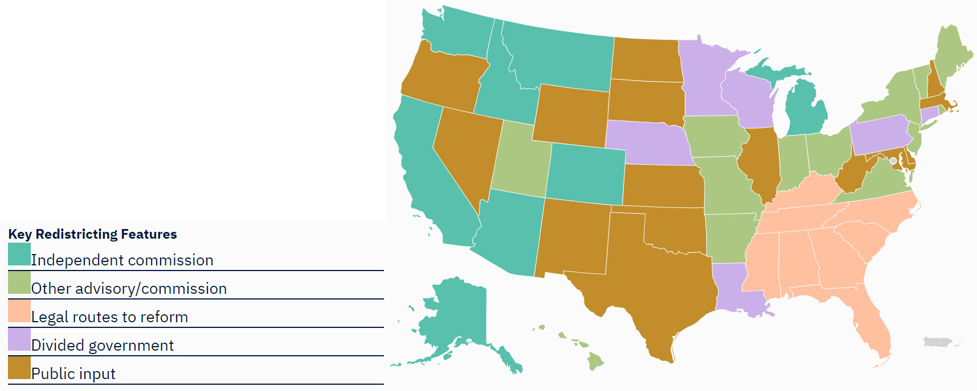

**Figure 2: State-by-state routes to redistricting reform.** From gerrymander.princeton.edu.

**Reform 2: Controlling runaway feedback in legislative power.** Because every state’s redistricting laws are different, reform must be designed on a state-by-state basis (**Figure 2**). Reform can be accomplished by establishing explicit fairness criteria, by shifting the power of redistricting away from the legislature and to a non-partisan or bipartisan commission, by robust public input, and by pursuing remedies in state courts. Some states have taken redistricting away from the legislature and put it into the hands of a commission during the past decade. Some state courts have mandated the redrawing of maps using anti-gerrymandering provisions, which are found in the laws and constitutions of all fifty states (Wang et al. 2019). The Pennsylvania Supreme Court undid a partisan Congressional gerrymander by asserting that the map violated state constitutional provisions mandating free and fair elections. However, this approach is available only in states where courts are ideologically or politically open to intervening. In states that allow a ballot initiative or referendum, citizens may vote directly to take line drawing out of the hands of the legislature.

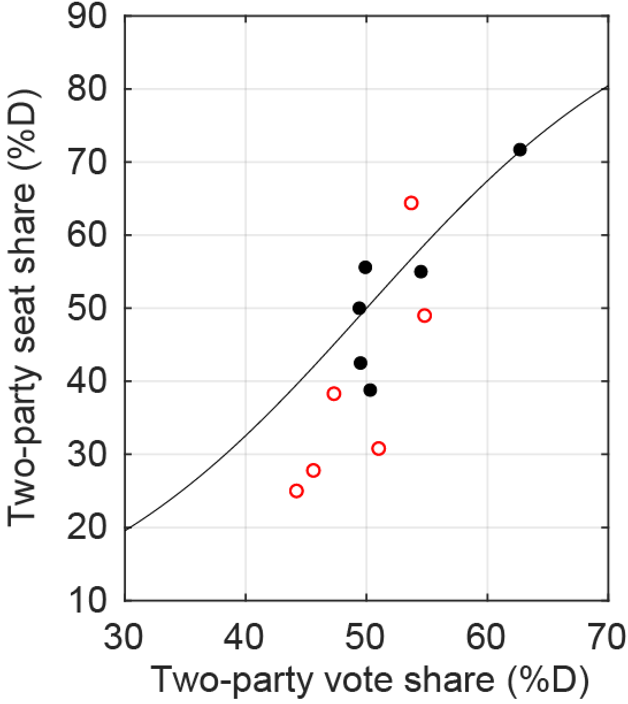**Figure 3. Reduction in representational distortions arising from intervention.** Filled black symbols indicate representation in six states with single-party control over redistricting. Open red circles indicate representation after judicial intervention and/or legislative redrawing, and bring representation closer to an ideal curve in which district partisanship is distributed symmetrically, yielding no advantage for either party.. The curve indicates a seats-votes relationship arising from a t-distribution of partisan vote share with a width parameter of 20 percentage points.

An easily measured consequence of independent redistricting is representational: it changes the number of elected officials from each party to a number that is commensurate with neutral districting (**Figure 3**). The polarization of individual winners is not reduced, especially in the short term. Examining a broad range of districts, the policy platform distance between Democratic and Republican candidates from the median voter is not closer in more competitive races (Hussey and Zaller, 2011). Thus the key moderating effect of reform might be to reduce the number of electeds who are unrepresentative of the state as a whole. Further study would be needed to determine how these effects are distributed in different types of districts, e.g. in constituencies that have been deliberately gerrymandered versus those whose lines were drawn more with respect to good-government criteria.

Other problems arise from independent or other non-legislature-based commissions. Commissions may still draw bipartisan gerrymanders which protect incumbents of both parties. And, because there is natural gerrymandering caused by the concentration of Democratic voters in the cities, reforms should look beyond compactness and maintaining city/county boundaries (Rodden 2018; Nagle 2019; Cervas and Grofman 2019). It may be more promising to examine new criteria for fairness, such as maintaining communities of interest.

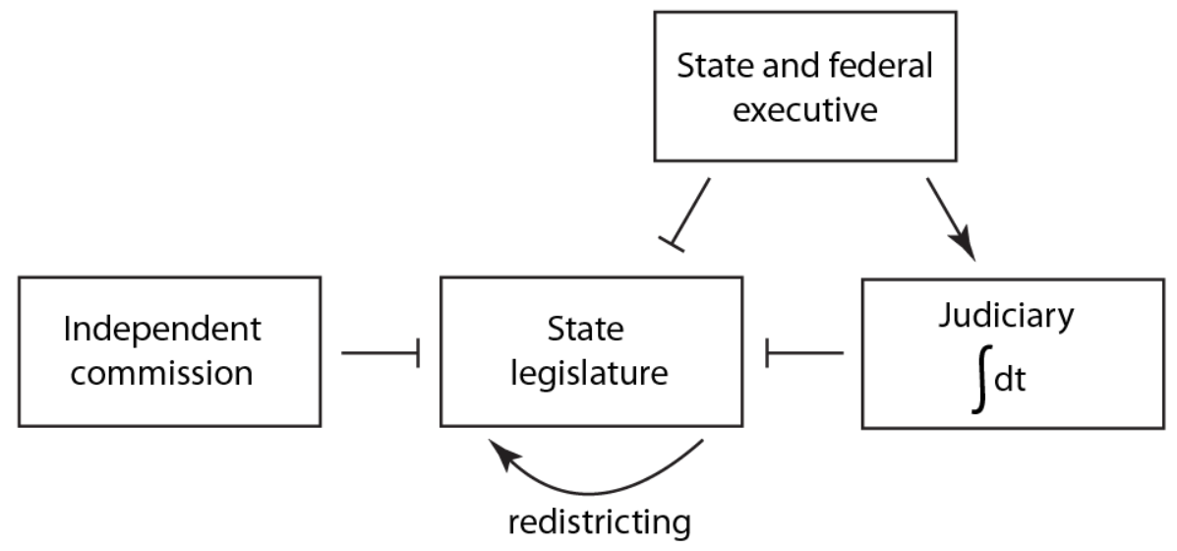

**Figure 4. A control diagram for representation.** Feedback mechanisms described in this article are diagrammed in terms of directional control. Arrows indicate positive feedback, and blunt symbols indicate negative feedback.

**A SYSTEMS-LEVEL VIEW OF REFORM**

The mechanisms we have described interact in a complex manner to drive representational outcomes. One way to understand them is to diagram them in a model of the sort one might find in a modern biology article (**Figure 4**). In this diagram, steps that have a positive effect on power or representation are indicated with arrows, and restraining or inhibitory steps are indicated with blunt symbols. It is possible to tell at a glance that the absence of inhibitory steps leads to runaway positive feedback.

The system shown in Figure 4 was largely devised under conditions of low polarization. But the consequences of the network’s operation are quite different under modern conditions. In particular, the positive feedback steps take on outsized importance. Modern reforms are aimed at disrupting these steps.

An alternative, though more challenging approach, is to defuse polarization itself. This may be a lengthy undertaking, since reaching current levels of polarization has been a fifty-year process. An alternative might be to identify interventions that reduce polarization. One approach would be to increase the dimensionality of political issue stands. Contests for the U.S. Congress have become increasingly nationalized, so that the destiny of a candidate for federal office is tied to national political forces (Abramowitz and Webster 2016; Carson et al. 2019; Jacobson 2019). But much less well understood is that the tightness of the national party constraint on congressional candidates has varied over time in a way that creates a self-reinforcing pattern of increasing polarization (Merrill et al. 2014, Brunell et al. 2016). Such “increased dimensionality” is available in some states such as Alaska, which has an independent political culture that was able to re-elect Senator Lisa Murkowski in 2016 in a write-in campaign after she failed to gain the Republican nomination. The recent introduction of an all-party top-four primary system in Alaska will test whether primary reform can take advantage of such a political environment.

Going forward, the broader problem is how to reach a stable outcome in which all citizen groups feel bought into a shared system of governance. As more reforms and changes are suggested, a complex-systems approach could be used to analyze responsiveness to voters, the ability of a legislature work deliberatively, or even to understand polarization itself. In these other cases, not all interactions are known, and their strengths not well quantified. But even writing down such a diagram provides a framework for research into evaluating the effectiveness and robustness of reform strategies.

**ACKNOWLEDGMENTS**

The authors thank the Electoral Innovation Lab for support, and Lee Drutman and Rebecca Moss for discussion.

**REFERENCES**

Abramowitz, A. I., & Webster, S. W. (2018). Negative Partisanship: Why Americans Dislike Parties But Behave Like Rabid Partisans. *Political Psychology*, *39*(S1), 119–135. https://doi.org/10.1111/pops.12479

Balkin, J. (2020) *The Cycles of Constitutional Time*. Oxford University Press.

Berg-Andersson, R.E. (2016) The Green Papers. https://www.thegreenpapers.com/P16/

Brunell, T. L., Grofman, B., & Merrill, S. (2016). Replacement in the U.S. House. *Party Politics*, *22*(4), 440–451. https://doi.org/10.1177/1354068814550430

Carson, J. L., Sievert, J., & Williamson, R. D. (2019). Nationalization and the Incumbency Advantage. *Political Research Quarterly*, 106591291988369. https://doi.org/10.1177/1065912919883696

Cervas, J. R., & Grofman, B. (2019). Are Presidential Inversions Inevitable? Comparing Eight Counterfactual Rules for Electing the U.S. President*. *Social Science Quarterly*, *100*(4), 1322–1342. https://doi.org/10.1111/ssqu.12634

Cervas, J., & Grofman, B. (2020). Legal, Political Science, and Economics Approaches to Measuring Malapportionment: The U.S. House, Senate, and Electoral College 1790–2010. *Social Science Quarterly*, *101*(6), 2238–2256. https://doi.org/10.1111/ssqu.12871

Cervas, J. R., & Grofman, B. (2020b). How Likely is Trump to Lose the Popular Vote but Win the Electoral College? *3Streams*.

Dahl, R. A. (2003). *How democratic is the American Constitution?* Yale University Press. https://yalebooks.yale.edu/book/9780300095241/how-democratic-american-constitution

Duca, J. V., & Saving, J. L. (2016). Income Inequality and Political Polarization: Time Series Evidence Over Nine Decades. *Review of Income and Wealth*, *62*(3), 445–466. https://doi.org/10.1111/roiw.12162

Duverger, M. (1954). *Political Parties*. Wiley.

Fiorina, M. P., & Abrams, S. J. (2008). Political Polarization in the American Public. *Annual Review of Political Science*, *11*(1), 563–588. https://doi.org/10.1146/annurev.polisci.11.053106.153836

Fraenkel, J., & Grofman, B. (2006). Does the Alternative Vote Foster Moderation in Ethnically Divided Societies? *Comparative Political Studies*, *39*(5), 623–651. https://doi.org/10.1177/0010414005285032

Fraenkel, J., & Grofman, B. (2004). A Neo-Downsian Model of the Alternative Vote as a Mechanism for Mitigating Ethnic Conflict in Plural Societies. *Public Choice*, *121*(3–4), 487–506. https://doi.org/10.1007/s11127-004-5794-5

Groeling, T. (2008). Who’s the Fairest of them All? An Empirical Test for Partisan Bias on ABC, CBS, NBC, and Fox News. *Presidential Studies Quarterly*, *38*(4), 631–657. https://doi.org/10.1111/j.1741-5705.2008.02668.x

Grofman, B. & Feld, S.L. (2004). If you like the alternative vote (aka the instant runoff), then you ought to know about the Coombs rule. Electoral Studies, 23(4):641-659.

Grofman, B., Troumpounis, O., & Xefteris, D. (2019). Electoral Competition with Primaries and Quality Asymmetries. *The Journal of Politics*, *81*(1), 260–273. https://doi.org/10.1086/700271

Guinier, L. (1994). *Tyranny of the Majority: Fundamental Fairness in Representative Democracy*. Free Press.

Hallett Jr., G. (1984). Proportional representation with the single transferable vote: A basic requirement for legislative elections. In *Choosing an electoral system: Issues and alternatives* (pp. 113–125). Praeger.

Hussey, W. & Zaller, J. (2011). Who Do Parties Represent? In Ennis and Wlezien (eds) *Who Gets Represented?* New York: Russell Sage 311-344.

Iyengar, S., Sood, G., & Lelkes, Y. (2012). Affect, not ideology: a social identity perspective on polarization. *Public Opinion Quarterly* 76(3):405-431.

Iyengar, S., Lelkes, Y., Levendusky, M. S., Malhotra, N., & Westwood, S. J. (2019). The origins and consequences of affective polarization in the United States. *Annual Review of Political Science*, *22*, 129–146. https://doi.org/10.1146/annurev-polisci-051117-073034

Jacobson, G. C. (2019). Extreme Referendum: Donald Trump and the 2018 Midterm Elections. *Political Science Quarterly*, *134*(1), 9–38. https://doi.org/10.1002/polq.12866

Massey, D. S. (2007). Categorically unequal: The American stratification system. In *Categorically Unequal: The American Stratification System*. https://doi.org/10.1177/009430610803700317

McCarty, N., Poole, K. T., & Rosenthal, H. (2016). *Polarized America, second edition: The Dance of Ideology and Unequal Riches*. MIT Press. https://books.google.com/books?id=58mpCwAAQBAJ

McDaniel, J. A. (2016). Writing the Rules to Rank the Candidates: Examining the Impact of Instant-Runoff Voting on Racial Group Turnout in San Francisco Mayoral Elections. *Journal of Urban Affairs*, *38*(3), 387–408. https://doi.org/10.1111/juaf.12209

McGhee, E., Masket, S., Shor, B., Rogers, S., & McCarty, N. (2014). A Primary Cause of Partisanship? Nomination Systems and Legislator Ideology. *American Journal of Political Science*, *58*(2), 337–351. https://doi.org/10.1111/ajps.12070

Merrill, S., Grofman, B., & Brunell, T. L. (2014). Modeling the electoral dynamics of party polarization in two-party legislatures. *Journal of Theoretical Politics*, *26*(4), 548–572. https://doi.org/10.1177/0951629813508847

Nagle, J. F. (2019). What Criteria Should Be Used for Redistricting Reform? *Election Law Journal: Rules, Politics, and Policy*, *18*(1), 63–77. https://doi.org/10.1089/elj.2018.0514

National Council of State Legislatures (2020). Redistricting Law 2020.

Piketty, T., & Saez, E. (2003). Income Inequality in the United States. *Quarterly Journal Of Economics*, *118*(1), 1913–1998. www.nber.org/papers/W8467.

Prior, M. (2007). *Post-Broadcast Democracy: How Media Choice Increases Inequality in Political Involvement and Polarizes Elections*. Cambridge University Press. https://books.google.com/books?id=o37mHuY7OWkC

Prior, M. (2013). Media and Political Polarization. *Annual Review of Political Science*, *16*(1), 101–127. https://doi.org/10.1146/annurev-polisci-100711-135242

Putnam, R. D., & Garrett, S. R. (2020). *The Upswing: How America Came Together a Century Ago and How We Can Do It Again*. Simon & Schuster. https://books.google.com/books?id=Wt2eDwAAQBAJ

Quinnipiac, author anonymous (2020). December 10, 2020 - 60% View Joe Biden's 2020 Presidential Victory As Legitimate, Quinnipiac University National Poll Finds; 77% Of Republicans Believe There Was Widespread Voter Fraud. Quinnipiac Poll Release. https://poll.qu.edu/national/release-detail?ReleaseID=3685

Rodden, J.A. (2019). *Why Cities Lose: The Deep Roots of the Urban-Rural Political Divide.* Basic Books.

Sen, A., & Maskin, E. (2018, June 11). Maine Tries A Better Way To Vote. *New York Times*, A21.

Starr, P. (2019). *Entrenchment: Wealth, Power, and the Constitution of Democratic Societies*. Yale University Press.

Stewart, A. J., McCarty, N., & Bryson, J. J. (2020). Polarization under rising inequality and economic decline. *Science Advances*, *6*(50), eabd4201. https://doi.org/10.1126/sciadv.abd4201

Tesler, M., & Sears, D. O. (2010). *Obama’s Race: The 2008 Election and the Dream of a Post-Racial America*. University of Chicago Press. https://books.google.com/books?id=geQxhys4rf8C

Tushnet, M. V. (2004). Constitutional Hardball. *J. Marshall L. Rev*, *37*(523), 2003–2004. https://scholarship.law.georgetown.edu/facpub/555http://ssrn.com/abstract=451960%0Ahttp://scholarship.law.georgetown.edu/facpub/555http://ssrn.com/abstract=451960http://scholarship.law.georgetown.edu/facpub

Wang, S. S.-H., Ober Jr., R. F., & Williams, B. (2019). Laboratories of Democracy Reform: State Constitutions and Partisan Gerrymandering. *Journal of Constitutional Law*, *22*(1), 203–290.

Wattenberg, M. P. (2004). The Changing Presidential Media Environment. *Presidential Studies Quarterly*, *34*(3), 557–572. https://doi.org/10.1111/j.1741-5705.2004.00212.x